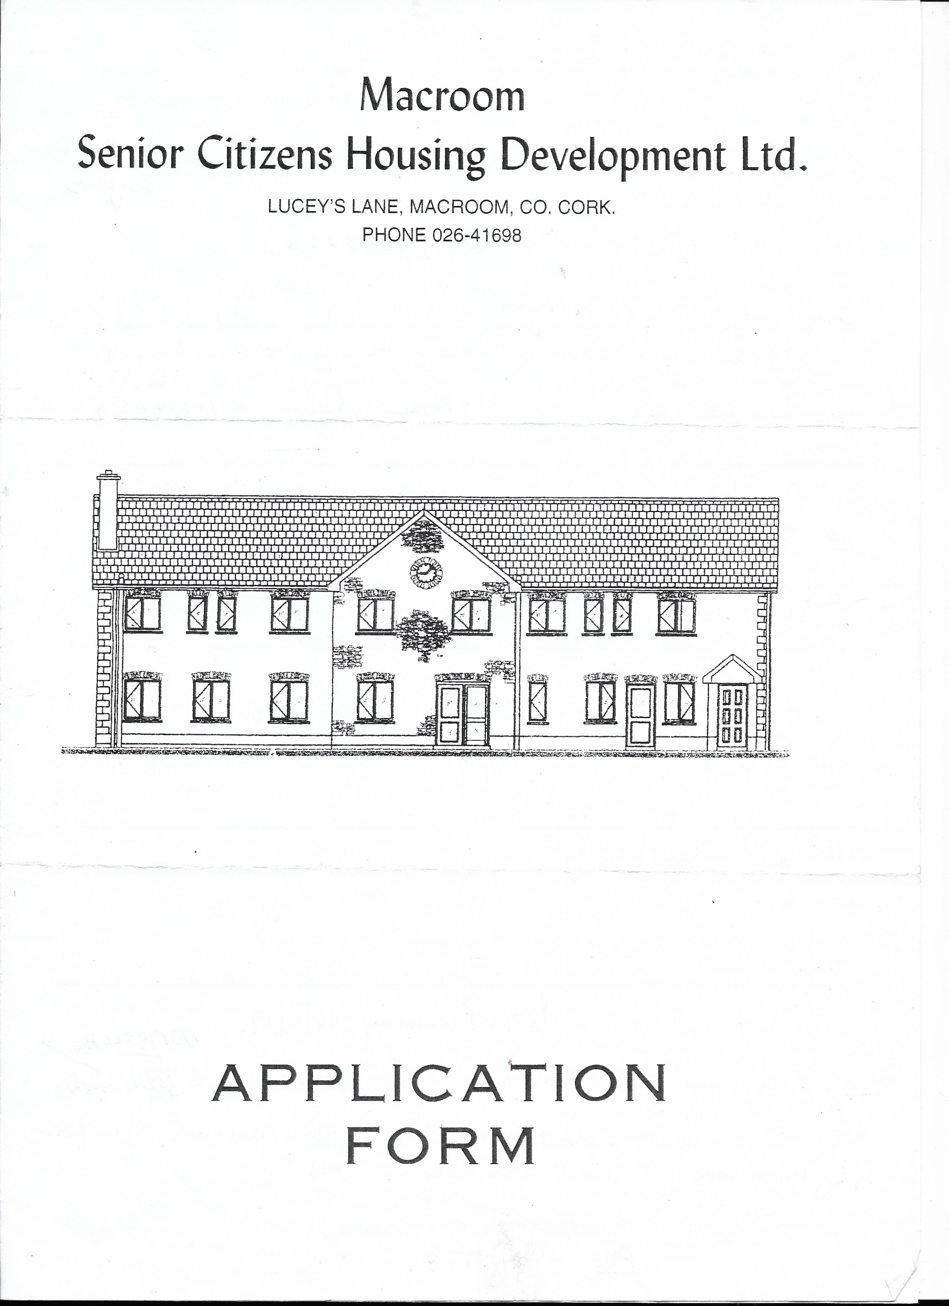

Please specify the accommodation you require: House

Residential Accommodation

Name __________________________________________________ Date of Birth ____________________________

Next of Kin _____________________________________________ Phone No. ______________________________

**QUALIFYING CONDITIONS**

Minimum age 60 years.

1. Must not own a property
2. Must not have sold a property within the last 5 years
3. Must have applied for social housing

**PRESENT LIVING ACCOMMODATION**

1. Owner Occupied

* 

1. Rental
2. Living Alone
3. Living with relatives (i.e. brother, sister son, daughter, other)

Name and address of owner of present accommodation

_______________________________________________________________________________________________

_______________________________________________________________________________________________

Please give details of any property previously owned by occupant

_______________________________________________________________________________________________

_______________________________________________________________________________________________

**PLEASE GIVE DETAILS OF INCOME**

Weekly wage €_______________________ Pension €___________________________________

Welfare Benefits €_____________________ Investments €___________________________________

_______________________________________________________________________________________________

**HEALTH**

Name of Doctor ________________________________________ Medical Card No. _________________________

Specify all medical conditions: ______________________________________________________________________________________________________________________________________________________________________________________________

Please state reasons why you should be considered for the House / Residential Accommodation

____________________________________________________________________________________________________________________________________________________________________________________________________________________________________________________________________________________________________________________________________________________________________________________________________________________________________________________________________________________________________________________________________________________________________________________________________________________________________________________________________________________________________________________________________________________________________________________________________________________________________________________________________________________________________________________________________________________________________________________________________________________________________________________________________________________________________________________________________________________________________________________

Do we have your permission to verify all the information as supplied by you? ________________________________

I declare that the information and particulars given by me on this application are true and correct

Signed _________________________________________________________ Date _________________________

**NOTE:**

The furnishing of false or misleading information is not advisable

Canvassing is not acceptable by Macroom Senior Citizens Housing Development Ltd.

**APPLICATION FORMS MUST BE RETURNED TO:**

**Macroom Senior Citizens Housing Development Ltd.**

**Sullane Haven, Lucey’s Lane, Macroom, Co. Cork. P12X432**

**Phone: 026 41698**

**Email: macroomseniorcitizens@gmail.com**

**Macroom Senior Citizens**

**Services Provided**

**Sheltered Housing**

**Residential Accommodation**

**Daily Lunch**

**Meals on Wheels**

**Chiropody**

**Laundry**

**Weekly Bingo (Thursday)**

**Tai Chi**

**Summer Outing**

**Christmas Dinner**